TESOL Kuwait Mini Conference
INNOVATIVE TRENDS IN LANGUAGE
LEARNING, PROFESSIONAL DEVELOPMENT, AND TEACHER EDUCATION DURING/POST THE
PANDEMIC

1

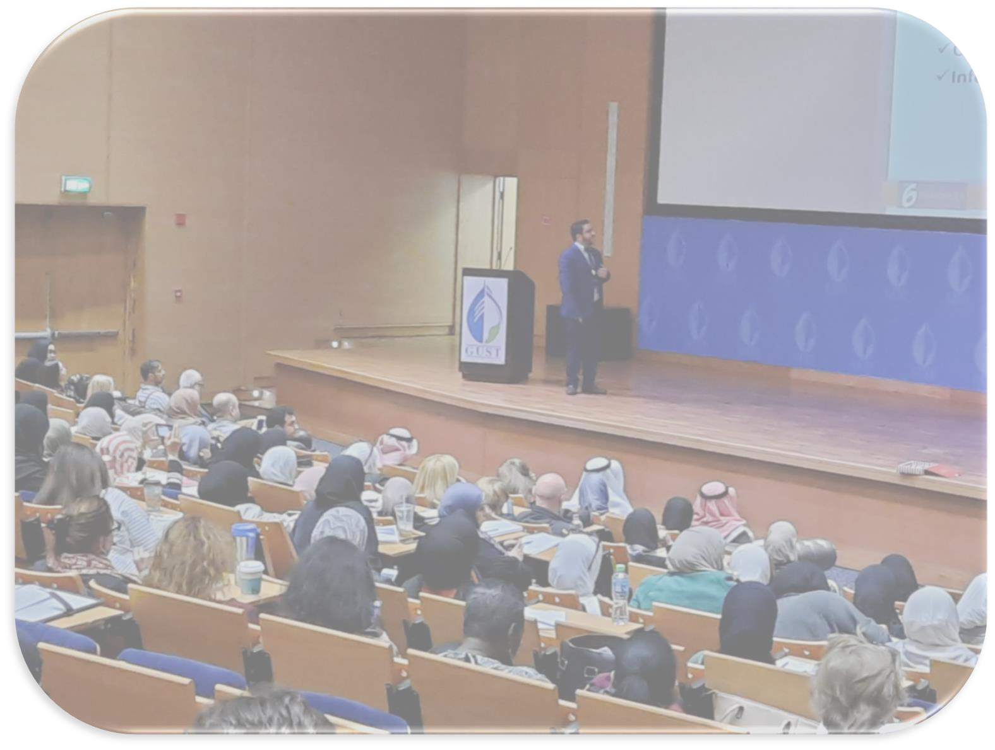

TESOL Kuwait Mini Conference

Contents

Welcome Message from TESOL Kuwait Conference Chair 3
About TESOL Kuwait 4
Mission Statement 4
TESOL Kuwait Board Members 5
2
Proposal Committee 5
Organizing Committee 5

TESOL Kuwait Mini Conference

Welcome Message

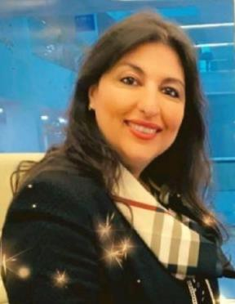

TESOL Kuwait Mini Conference

Dr. Marine Milad – Conference Chair
Assistant Professor at the Arab Open University

On behalf of the TESOL organizing committee as per the year 2020, it is my great pleasure to welcome you all to the Mini Conference at AOU, Kuwait. I am extremely privileged to be hosting such an honorable event in which educators from all over the world get to meet, network, and mutually share diversified knowledge.
The main theme of this conference revolves around teaching and learning languages during & post the pandemic. The conference aims to enhance teacher performance and promote cooperation through highlighting the role of individual and institutional professional development. It also aims at sharing good practices and receiving feedback in the field of language learning and teaching.
Last but not least, I am pleased to serve this international event and am very grateful for your participation and attendance. I wish you all a very insightful, and entertaining learning experience throughout our sessions.

Sincerely yours, Dr. Marin Milad Conference Chair

About TESOL Kuwait

TESOL Kuwait Mini Conference

TESOL Kuwait is an affiliate of the international association TESOL, Teachers of English to Speakers of Other Languages. Our common mission is to advance professional expertise in English language teaching and learning for speakers of other languages.

Mission Statement
TESOL Kuwait is a professional, non-profit organization whose objectives are:
- To work cooperatively towards the improvement of instruction in all programs which seek to provide learners with an opportunity to acquire English language skills and proficiency.
- To provide opportunities for study and research.
- To encourage professional development, participation, and leadership at the local, national, and international levels.
- To promote intercultural understanding and effective cross-cultural communication.
- To cooperate in appropriate ways with other groups having similar concerns.

TESOL Kuwait Mini Conference

Ann Newman | President
Dr. Reem AlQenaie | President Elect
Dr. Marine Milad | Conference Chair
Najebah Marafie | Treasurer
Abdullatif Al-Shatti | Secretary and Conference Co-Chair
Veronica Zvinca | Membership Chair
Fatemah Husain | Volunteers Chair
Fares Al Shammari | Publicity Chair
Fawaz Al Fares | Sponsorship Chair

Proposal Committee

Dr. Marine Milad | Proposal committee member
Dr. Raniya Yaquoob | Proposal committee member

Organizing Committee

Ms. Amal Mohamed | Organizer
Ms. Zainab Khalil | Organizer
Ms. Fatma Almutairi | Organizer

Venue

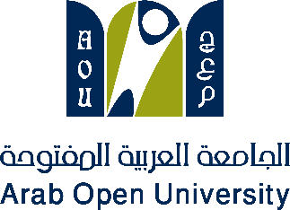
TESOL Kuwait Mini Conference
About the university:
The Arab Open University was founded in 2022.
The AOU is unique in the Arab world by virtue of its partnership with The Open University (UK).

TESOL Kuwait Mini Conference

Time | Description | Location
09:30 am - 10:00 am | Registration & Coffee break | Registration Area &  Qutaiba Alghanem Auditorium
10:00 am – 10:30 am | Opening - President's speech:  Anne Newman  Dean of faculty of Languages AOU:  Prof. Aziz Thabit
10:30 am - 11:15 am | Dr. Louise Ohashi  Associate Professor at Gakushuin University, Japan  Exploring the Role of Machine Translation in Language Education
11:15 am - 12:00 pm | Martin Curtis  Academic Director at Garnet Education ELT Teacher & Teacher Trainer  Workshop: Staging a Lesson: Online vs Offline
12:00 pm - 12:30 pm | Fatma Fayez  Lecturer at Arab Open University, Kuwait  AOU Toastmasters: Impromptu Speech
12:30 pm - 01:00 pm | Lunch & Prayer break
01:00 pm - 01:45 pm | Dr Christina Gkonou  Associate Professor of TESOL and MA TESOL Programme Leader in the Department of Language and Linguistics at the University of Essex, UK. Understanding socio-emotional competencies in 21st century language  classrooms
01:45 pm - 02:15 pm | Dr. Marine Milad  Assistant Professor at Arab Open University, Kuwait  CALL Project-Based Program to Enhance Student-Teachers’ TEFL Skills
02:15 pm - 03:00 pm | Natasha E. Feghali  ESL Intervention specialist, ACA Language Leaners in an increasingly digital context.
03:00 pm - 04:00 pm | Ghadeer Alsanad  Lecturer at Arab Open University, Kuwait Workshop: Postgraduate Study Abroad Mayy Elhayawi  E-Learning & Accessibility Director- TEFL Wonderland  Workshop: Animate to Teach and Gamify to Practice: Utilizing Authoring Tools to Create Unique E-Learning Experiences

TESOL Kuwait Mini Conference

04:00 pm - 04:30 pm | Mohamed Amin & Dani Tawfik  AOU Students  AOU Toastmasters: Trivia Game
04:30 pm - 05:00 pm | Dr Nour Dakkak  Assistant Professor at Arab Open University, Kuwait  Salman Almutairi & Abdullah Sabae  AOU Students  Dramatization: Breaklight: A Theatrical Reflection on Language and Identity

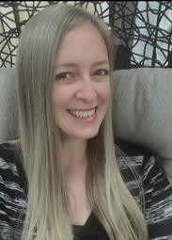
TESOL Kuwait Mini Conference
Keynote Speakers
Dr. Louise Ohashi
Associate Professor at Gakushuin University, Japan

Exploring the Role of Machine Translation in Language Education
Abstract:

Machine translation (MT) is used by millions of people around the world every day, with the most widely used translator, Google Translate, supporting translations in 133 languages. MT has developed dramatically since switching to neural network translation (Google in 2016, DeepL in 2017), with accurate output becoming increasingly common. This tool certainly has benefits in areas such tourism and sales, but when considered from the perspective of language education, is it a friend or a foe? MT can instantaneously
translate input from a student’s first language to their target language, raising concerns from some educators that this leads to misuse (Kennedy, 2022; Ohashi, 2022). However, this real-world tool is used widely in workplaces across the globe and can be used constructively for language development, so completely banning it from language courses does not seem advisable. Rather, in this session, it will be suggested that educators and researchers further explore how students can be directed to use MT in ways that will help them to improve their language skills and reduce the likelihood of misuse, particularly in ways that could be considered academic misconduct. There have already been calls for its integration into language education within boundaries. For example, Kol, Schcolnik, and Spector-Cohen (2018) noted that Google Translate can be useful for writing tasks at
university level if students can “critically assess and correct the output” (p. 50). Similarly, Lee (2019) cautioned that MT could be useful for learners, but emphasized the need for teachers to understand its limitations and provide student guidance. The presenter will share her own work (Ohashi, 2022) to make similar calls, introduce relevant studies by

TESOL Kuwait Mini Conference
others in the field of language education, and based on this, make suggestions for
educators and institutions to consider.
Bio:
Dr. Louise Ohashi is an associate professor at Gakushuin University who specializes in SLA and language education. Her research interests include learner autonomy, motivation, and CALL/MALL. She has a passion for language learning too, with various levels of proficiency in five foreign languages. Twitter:
@OhashiLou.

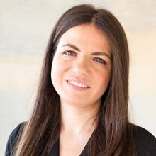
TESOL Kuwait Mini Conference

Dr Christina Gkonou
Associate Professor of TESOL and MA TESOL Programme Leader in the Department of Language and Linguistics at the University of Essex, UK.

Understanding socio-emotional competencies in 21st century language classrooms

Abstract:
Emotions are at the centre of all human behaviour, and learning and teaching are no exception. The omnipresence of emotions makes it necessary for learners and teachers to develop a set of socio-emotional skills, which encompass the following three key life competencies: a) self-awareness, or identifying and talking about emotions; b) self-
regulation, or managing one’s own emotions; and c) empathy and relationship skills. Within psychology, these competencies are broadly categorised under the constructs of emotional intelligence (EI) and social intelligence (SI), two terms which became widely known through Daniel Goleman’s (1995, 2006) bestselling popular science books. In this presentation, I focus on reviewing key theories of EI and SI, methods of researching them in language education, and their application in foreign language classrooms through activities and the use of literature.

Bio:
Dr. Christina Gkonou is Associate Professor of TESOL and MA TESOL Programme Leader in the Department of Language and Linguistics at the University of Essex, UK. She convenes postgraduate modules on language teacher education and development, and on psychological aspects surrounding the foreign language learning and teaching experience. She is co-editor of New Directions in Language Learning Psychology (with Sarah Mercer and Dietmar Tatzl), New Insights into Language Anxiety: Theory, Research and Educational Implications (with Jean-Marc Dewaele and Mark Daubney), and The Emotional

TESOL Kuwait Mini Conference
Rollercoaster of Language Teaching (with Jean-Marc Dewaele and Jim King). She is also co-
author of MYE: Managing Your Emotions Questionnaire (with Rebecca L. Oxford) and has published a number of research articles in international, peer-reviewed journals. Her new co-authored book (with Kate Brierton) for Cambridge University Press is on Cultivating Teacher Wellbeing and will be out in October 2022.

Abstract:
Staging a Lesson: Online vs Offline

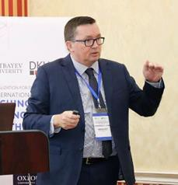During the COVID 19 pandemic, teachers have been forced to reappraise traditional approaches to lesson planning. In this highly interactive workshop, teachers will be given a different perspective into lesson planning for the classroom & how this compares with planning with the same resources for online teaching.
TESOL Kuwait Mini Conference
Workshops

Martin Curtis
Academic Director at Garnet Education
Learning Outcomes:
- Dissecting a lesson: 8 stages.
- Staging the ideal lesson.
- TTT vs PPP vs ESAP framework for online lessons Key Topics:
- Deconstructing a sample lesson from video.
- Comparing and contrasting the teacher’s book to reality.
- Staging the ideal lesson
- Lesson plan templates.

TESOL Kuwait Mini Conference

Bio:
Martin Curtis is a qualified and experienced ELT Teacher & Teacher Trainer, and is the Academic Director at Garnet Education. He has over twenty years’ experience from a broad variety of teaching contexts. He has taught primary and secondary English in
Greece, trained Russian teachers to become English teachers in Poland, taught English for Specific Purposes in Russia, Business English to jobseekers & refugees in Germany, and has also been a Head Teacher at Abu Dhabi University. He has been a Teacher Trainer since 2011, and trained extensively for Pearson Education and Oxford University Press in the Middle East and Central Asia prior to joining Garnet Education in 2021.

TESOL Kuwait Mini Conference
Postgraduate Study Abroad

Ghadeer Alsanad
Lecturer at Arab Open University, Kuwait

Abstract:
Studying abroad will open you up to new worlds, allowing you to work closely with major specialists in your field. Postgraduate studies can help advance your career at any level. This presentation will help with ways to properly apply for a postgraduate degree abroad. Starting from choosing the right postgraduate course/programme, to the required documents and Ministry of Higher Education procedures for equivalency. At the end of the presentation, a brief practical application will be conducted and a Q&A session will be opened.

Bio:
Ghadeer Alsanad is a lecturer at Arab Open University, Kuwait. She obtained her BA in English Language and Literature (2011) from Arab Open University. In 2013, Ghadeer received her MA in Romantic and Victorian Literary Studies from Durham University, UK. Her research interests are Victorian studies, slavery studies, cross-cultural and racial rhetoric, and political discourse analysis.

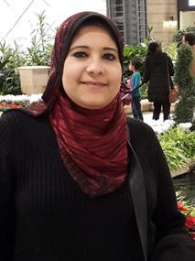
TESOL Kuwait Mini Conference
Animate to Teach and Gamify to Practice: Utilizing Authoring Tools to Create Unique E-Learning Experiences
Dr. Mayy Elhayawi
E-Learning & Accessibility Director- TEFL Wonderland

Abstract:
Can you turn the boredom of traditional teaching into sheer fun? Can you create a friendly learning atmosphere enlivened with competitiveness, collaboration, motivation and enjoyment? Can you plan a self-paced or a blended course that makes you hardly visible while autonomous learning is enthusiastically going on? Are you confident enough to take the backseat, share control with learners or even hand it over entirely to them? To help you answer these questions, this talk will investigate how the boredom of 'chalk and talk' can be turned into an exciting expedition for intellectual discovery and emotional inspiration. Exploring the tips and tricks for animating and gamifying online learning experiences (through integrating multiple authoring tools) will provide attendees with the magic formula for creating a positive learning atmosphere wherein students feel excited, confident and ready to take risks. No longer acting as the benevolent dictator who possesses all knowledge, and no more playing the role of passive subjects who cannot undertake the responsibility of their own education, both the teacher and his/her students will generate productive environments valued most for less teaching, more learning, and greater enjoyment.

TESOL Kuwait Mini Conference

Bio:
Mayy is an associate professor of English literature, educational technology consultant, teacher trainer and IELTS examiner in Canada. She has vast teaching, training, instructional design, accessibility, quality control and assessment experience acquired

through teaching at different universities, developing tens of academic and professional development courses, and training hundreds of teachers and senior executives in Canada, USA, Asia, Europe and the Middle East. Mayy was a Fulbright post-doctoral scholar at Stanford University and a guest speaker at many universities including Yale, Stanford, UC Berkeley, A&M University of Texas and San Francisco State University

TESOL Kuwait Mini Conference
Presentations

Dr. Marin Milad – Conference Chair
Assistant Professor at the Arab Open University

CALL Project-Based Program to Enhance Student-Teachers’ TEFL Skills
Abstract:
Students-teachers are students who study to become Teaching English as a Foreign language (TEFL) teachers. They receive teaching training, observe certified teachers’ teachings performance, and do some supervised teaching practices in EFL classrooms for the elementary and secondary stages. The presentation aims at introducing a supplementary program to support a practical TEFL course and to develop Arab Open University (AOU) student-teachers’ skills of teaching listening, speaking, reading, writing, and vocabulary for elementary stage pupils through a language project that focuses on instilling social values in these young pupils. This has been mainly done with samples of practical examples, interactive discussions and tasks of practical nature posted on Learning Management System (LMS) in the light of Computer-Assisted Language Learning (CALL) in accordance with the course Intended Learning Outcomes (ILOs). The Constructoactive Model, developed by Sahakian and Ghoneim (2007), has been adopted to promote student- teachers’ knowledge of different TEFL methods. In addition, Stoller's (1997) model for developing project work has adopted to familiarize young pupils with good social values and their related vocabulary items. The supplementary program has proved to be helpful in promoting the student-teachers’ performance in teaching different language skills, writing lesson plans and giving demo class presentations for the developed lesson plans by using PowerPoint/Prezi presentations, open-source video/audio links and a number of software programs (such as Kahoot, Quizlet, and Grammarly).

TESOL Kuwait Mini Conference

Bio
Dr. Marine Milad is an assistant professor of English Language and Applied Linguistics at Arab Open University (AOU), Kuwait Branch. She has a PhD in TEFL, Curriculum and Instructions from Cairo University with the grade of distinction. She also attained a Master Level Course in ESL/EFL Assessment Techniques from Indiana University, Bloomington,
U.S.A. Currently, she is the General Course Chair for three courses: academic writing, Teaching English as a Foreign Language (TEFL) and Exploring Grammar in Context across eight AOU branches. She has delivered several academic and technical presentations in local and international conferences in the field of Language Learning, E-Learning, Blended Learning, Multiple Intelligences and Brain Colour, Constructivism, Learning by Doing, educational reform and soft skills. Dr. Marine is currently TESOL Kuwait Past President, affiliated by TESOL International.

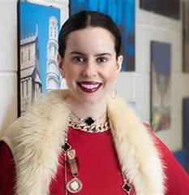
TESOL Kuwait Mini Conference
Language Learners in an increasingly digital context

Abstract:
This session will focus on the ELL Language Learner on a digital platform and what are the shortfalls and positive growths that educators can use to enhance the experience of learners on those digital platforms. Why do some learners thrive and others dive? This session will give examples and ideas to educators on how to teach and enhance learning via digital platforms for ELL leaners with allows learners globally to be engaged in education and gives way for all to access education.

Bio:
Natasha E. Feghali, an award winning Canadian for her philanthropy in community and dedication to education and the community. She is a Stanford University Fellow of the Draper Hills School for Democracy and Democratic Rule. She is the recipient of the 40 Under 40 United Way/ Leadership Windsor-Essex Award 2018, the Sovereign Canadian Medal in 2015 and the Odyssey Award University of Windsor 2018.

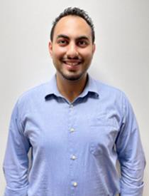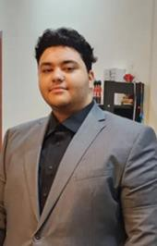
Mohammed Amin
Dani Tawfik

Abstract
Impromptu Speech

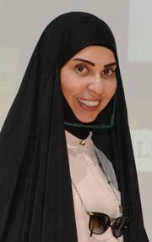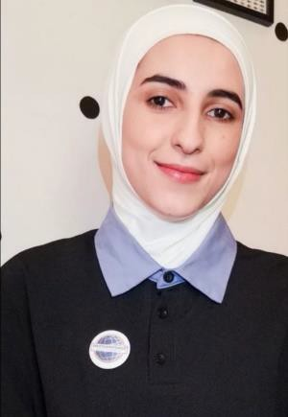The impromptu ( table topics) speech is one of the important segments and most successful segments in a toastmasters' meeting. Taking on this role improves confidence and the speaker's impromptu speaking skills. the speaker within 1-2 minutes has to come up and develop a speech on an unprepared topic. This exercise can in addition to enhance the speakers' skill in developing a speech in a 30 second period of thinking, add the fun and the challenge element to the meeting.
TESOL Kuwait Mini Conference
AOU Toastmasters
Aroob Marwan
Ms. Fatama Fayez Lecture at AOU

TESOL Kuwait Mini Conference
Bio:
Fatma Mohd. Fayez, a tutor at AOU since 2003, Specialized in TEFL and holds a master's in international teaching from Framingham State Collage- UAS and a Masters in Language and Linguistics from Essex University - UK. I have been working in the field of teaching English since 1985 by teaching in public schools before working in the university. in 2013, I chartered AOU toastmaster, as a speaking Club in the university to help the students develop their communication and leadership skills.

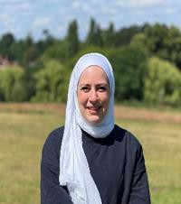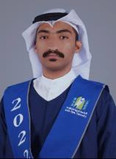
TESOL Kuwait Mini Conference
Dramatization
Dr. Nour Dakkak
Abdullah Sabae
Salman Almutairi

Breaklight: A Theatrical Reflection on Language and Identity Abstract:
Breaklight is a short play written by Salman Almutairi and performed by Abdullah Sabae and Salman Almutairi. The play is a dialogue on identity, language and culture. It expresses the conflicts and concerns that writers and artists may deal with as a result of colonialism and cultural globalisation.

Bios:
- Nour Dakkak is an assistant professor in English Literature at the Arab Open University, Kuwait. Her research interests include twentieth century British literature and culture and landscape writing. She is the co-editor of Anticipatory Materialisms in Literature and Philosophy, 1790-1930 with Jo Carruthers and Rebecca Spence, and Sandscapes: Writing the British Seaside with Jo Carruthers. She’s currently working on a monograph on E. M. Forster’s Material Humanism.

- Salman Almutairi is the writer, director and performer in the play Breaklight has just graduated with a BA in English language and literature from the Arab Open University in Kuwait. Salman had multiple workshops in theatre. He was Awarded for the best-designed costumes by the Higher Institute of Dramatic Arts in 2020

TESOL Kuwait Mini Conference
and was awarded the best actor for monodrama by the Higher Institute of Arts and
Crafts of Sidi Bouzid in 2020.
- Abdullah Sabae, the main performer in the play Breaklight, has just graduated with a BA in English Language and Literature from the Arab Open University in Kuwait. Abdullah questions identity and belonging a lot. He is a painter and is passionate
about everything related to art.

